Lab 5. Using Parameters

# Setup

1. Go to **File -> New -> Spring Starter Project** to create a new Spring Project
2. Type the following information in the wizard:

**Service URL:** <https://start.spring.io>

**Name:** usingParams

**Group:** mx.tec.lab

**Artifact**: testDatabase

**Description:** Using Parameters Test Lab

**Package:** mx.tec.lab

1. Select Spring Boot Version 2.2.5 and click Finish
2. Open pom.xml file and verify you have the following dependencies

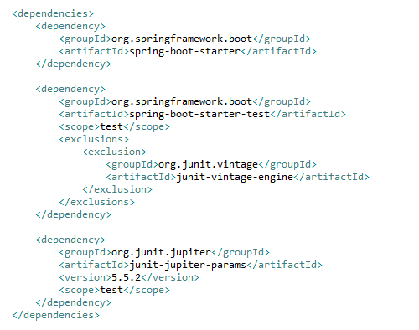

1. Verify that you have the **UsingParamsApplication** class in src/main/java (Package Explorer)
2. Verify that you have the **UsingParamsApplicationTests** class in src/test/java (Package Explorer)
3. Click on **Run As -> Maven clean**
4. Verify that clean was successful in the Console
5. Click on **Run As -> Maven install**
6. Verify that install was successful in the Console

# Exercise

1. Create Class **SafeAdditionUtil** in /src/main/java

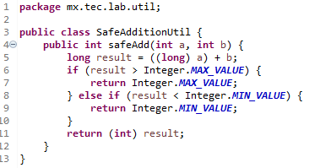

1. Delete Class **UsingParamsApplicationTests**
2. Create Class **SafeAdditionUtilTest** in /src/test/java

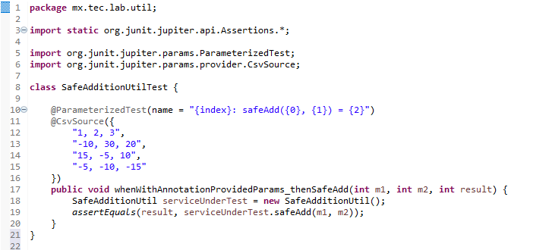

1. Run **Junit Test** and see the results.
2. Add a provider method

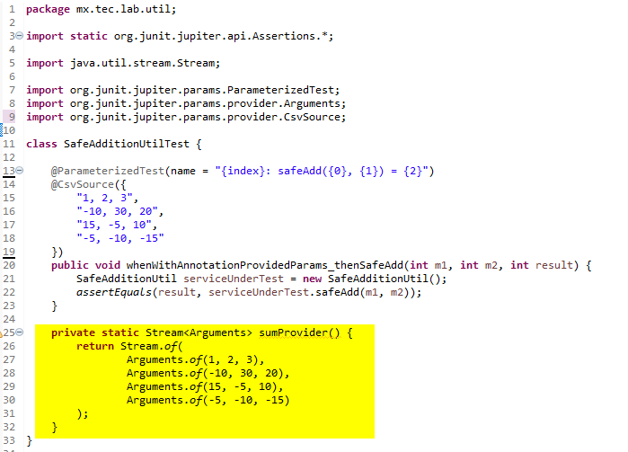

1. Comment the CsvSource annotation and add the MethodSource Annotation

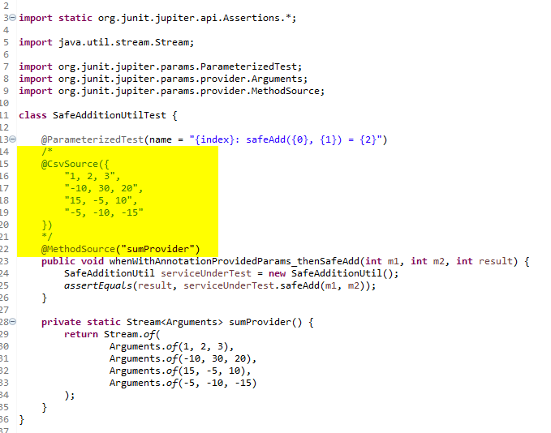

1. Run **Junit Test** and see the results.
2. Create File **JunitParamsTestParameters.csv** in /src/test/resources

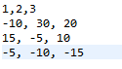

1. Comment the MethodSource annotation and add the CsvFileSource annotation

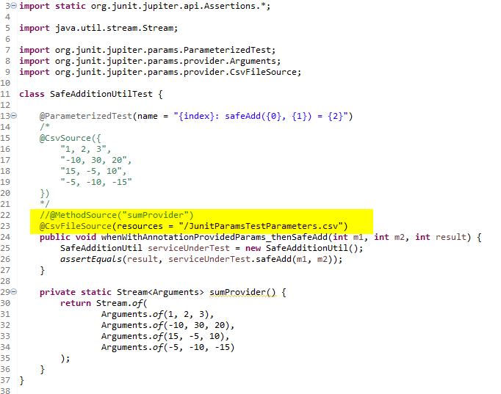

1. Run **Junit Test** and see the results.

# Challenge

1. What is the difference between @Test and @ParameterizedTest annotation?
2. What is the advantage of having the parameters together to the test method?
3. What is the advantage of having the parameters in another method?
4. What is the advantage of having the parameters in a csv file?
5. Provide an example when to use the csv file and when to use a method with the test data?